Name___________________________ Per_______ Date____________

DBQ: The Cold War and the Red Scare

Background information:
During the Cold War, there was a fear of Communism being spread within the United States. This time period was known as the “Red Scare.” The paranoia that the Red Scare caused resulted in the U.S. government to jumpstart a “witch hunt” against anyone who was believed to be communists by establishing the HUAC (House Committee on Un-American Activities). They decided to target the entertainment industry, including well-known celebrities. McCarthyism came from Senator McCarthy, who due to political motives took many people, including government officials, to trial on the basis that they were involved with the communist party. Many of those were accused had little to no evidence justifying that they belonged to the Communist party.

Instructions:
On Part A, answer the following questions on the each primary source document. On Part B, answer the following prompt in a response.

Part A

Document 1: “How Communism Works”
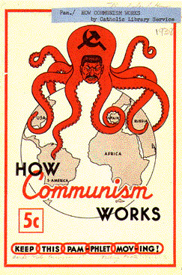

- Who might the octopus represent?

- Why did the author choose an octopus as the symbol choose as the symbol for
Communism in this poster?

- What is the message of this poster?

- Who paid for the production of this poster and why is it important to consider the source?

Document 2: “It’s Okay, We’re Hunting Communists”
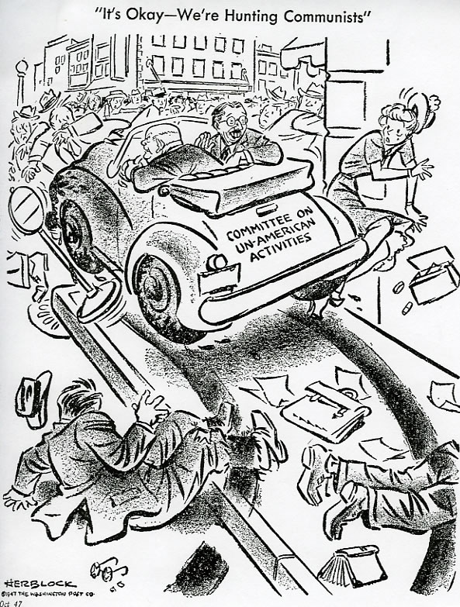

- What is happening in this cartoon?

- How does the House Committee on Un-American activities (HUAC) car parallel the HUAC activities of the time?

- How are people affected by the HUAC car in the cartoon?

- What do you think is the author’s attitude toward HUAC?

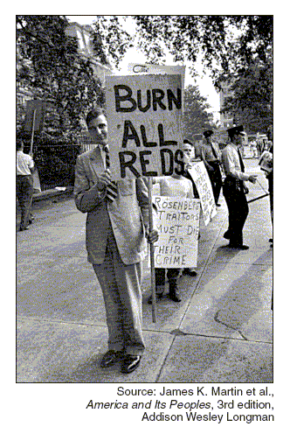
Document 3: “Rosenberg Trial Spectators”

- Describe the feelings and attitudes in the U.S. at this time in history that accounts for the signs in this photograph.

- What could be a potential use of this picture in 1954?

- Why did the photographer take this picture?

Document 4: Transcript of the Senate Resolution 301: Censure of Senator Joseph McCarthy (1954)

Sec 2. The Senator from Wisconsin, Mr. McCarthy…in stating to the press on November 4, 1954, that the special senate session…was a “lynch-party”, in repeatedly describing this special Senate session as a “lynch bee”…in characterizing the [Select Committee] as the “unwitting handmaiden, “involuntarily agent” and “attorneys-in-fact” of the Communist party...[McCarthy] acted contrary to senatorial ethics and tended to bring the Senate into dishonor and disrepute, to obstruct the constitutional processes of the Senate, and to impair its dignity and such conduct is hereby condemned.

- According to the document, how did Senator McCarthy characterize the activities of the Select Committee?

- Why did the Senate decide to censure McCarthy?

Part B:

Prompt: Write a response using the primary sources (documents) above as evidence to describe the underlying theme/motive behind anti-communist propaganda during the Cold War.

